
LAGOS STATE UNIVERSITY OF SCIENCE AND
TECHNOLOGY (LASUSTECH)
COMPUTERPROGRAMMINGII
Duration: 3hrs
INSTRUCTIONS TO CANDIDATES: This paper has 3 pagesand4 questions
Answer ALL questions

Question 1 (13 marks)
- Define the following terms
  - Interface of a class
  - Implementation Ofa class
  - Reference variable
  - Heap
  - Scope
(5 marks]
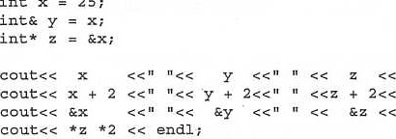
endl; endl; endl;
int
x
=
25
- If the variable x is stored at location Ox2FAO, and z is stored at Ox5D31. What is the output of the above code segment? (Assume 4 byte integers)
[8 marks]

PLEASE TURN OVER
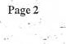

Question 2 (18 marks)
- Suppose we have a sorted array A which has N integers. Write code segments which use (i) a linear search approach
(ii) a binary search approach to determine the number Of elements in A, thut are larger than a search key k.
Note that in both instances, you are expected to make use ofthe fact that the array is sorted.
[4 + 8 marks]
- For each sequence below, indicate the maximum number ofpasses of (i) Bubble sort,
(ii) Selection sort, and (iii) Insertion sort which could produce the list shown.
    - 5, 11, 35, 57,26, 19, 9, 4
    - 35, 5, 11, 26, 19, 9, 4, 57
    - 5, Il, 19, 9, 4, 26, 35, 57
    - 4, 5, 57, 35, 11, 26, 19, 9
[6 marks]

Question 3 (IS marks)
- State one advantage and one disadvantage of recursion. [2 marks]
- State one way in Which recursion and iteration are similar and one way in which they are different. [2 marks]
- The following two recursive functions pl and p2 perform the same task. Show the function call tree for pl (5) and for p2 (5) . What value is returned by the functions?
[6 + 6 + 2 marks]
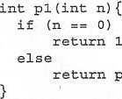 pl (11—1) ;  1  ;  pl  (n— |  | 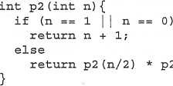 | (11+1) ,/2) ;
PLEASE TURN OVER
Page 3

Question 4 (36 marks)
class Queue
private :
Node* frontPtr; //pointer to the front of the Queue
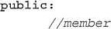 functions .
Assuming an appropriately defined Node class exists, implement the member functions of the dynamic Queue ADT which has been partially defined above.
A default constructor, (ii) A destructor.
(iii) A function called dequeue which returns the integer element at the front ofthe queue and removes it from the queue.
A function called engueue which inserts an integer at the back of the queue,
[4 +4 + 4 + 8 marks]
(b) Suppose we perform an intermixed sequence of insert and remove operations to an ADT such that the integers 1 to 10 are inserted as follows:
1 is inserted before 2, 2 is inserted before 3, 3 is inserted before 4, and so on.
For each sequence shown below, write down the first impossible integer removed from the sequence, or O if110 such impossible remove operation exists, assuming the ADT is
- A stack
- A queue
A. 1, 2, 3, 45, 10, 9, g,
B.2, 3,4, 5, 6, 7,
c. 1, 5, 7, 6, 4, 10
[ (2+2) + (2+2) + (2+2) marks]
Give two example applications (each) for the stack and queue ADTs.
[2 +2 marks]
-END OF PAPER-

